

Rhode Island GHG Emissions Scenarios: 2007 Update
A Memo to the Rhode Island DEM

Charles Heaps
Stockholm Environment Institute - U.S. Center
11 Curtis Avenue
Somerville, MA 02144
Web: www.sei-us.org
Email: charlie.heaps@sei-us.org

Part 1: Methodology, Data Sources and Major Assumptions
The GHG mitigation assessment for Rhode Island (RI) is based on relatively straightforward accounting estimates of baselines and GHG savings from various policies and measures. The baseline uses standard sources of historical data describing energy consumption in Rhode Island for 1960-2003 coupled with a set of emission factors for each sector and fuel, taken from the EIA’s State Energy Data. Consumption is projected using the growth rates for New England in the EIA’s Annual Energy Outlook 2006. On the supply-side we have used a consumption based approach. Rather than model the power plants actually located in RI we have modeled the baseline mix of power plants that provide electricity in New England. Baseline data on the historical and likely future New England mix of plants along with their generation efficiency is also taken from AEO 2006.
Estimates of savings and costs of demand-side measures were provided by the various consultants to the RI GHG stakeholder process. These were modeled as “wedges” of negative energy consumption and negative emissions that were subtracted from the baseline scenario within each appropriate sector.
On the supply side, the effects of a Renewable Portfolio Standard as well as the supply-side effects of any demand-side electrical efficiency improvements were modeled with the simplifying assumption that Natural Gas power plants throughout New England would be avoided on the margin for any resulting reductions in electricity demand. Thus, the basic method was to subtract absolute amounts of energy dispatched from natural gas power plants from the original amounts modeled in the baseline scenario. A somewhat similar approach was used for modeling the impacts of the Regional Greenhouse Gas Initiative (RGGI). Based on reports from the RGGI process we allocated a fraction of the change in generation mix expected to occur as a result of RGGI to RI based on RI’s consumption share of total generation in the RGGI region.
Measures are combined into three scenarios for analysis and presentational purposes:
- Implemented: measures that are already being actively implemented in Rhode Island.
- Implemented + finalized: the above measures plus measures that are expected to be implemented very soon (e.g. within a year).
- Implemented + finalized + under development: all of the previous measures plus those that are currently only being considered by the RI GHG Stakeholder Group

Historical fuel prices are also taken from the EIA’s State Energy Data, while future fuel price projections are taken from the EIA’ Annual Energy Outlook for 2007.
The whole scenario analysis of energy, GHG and cost accounts for the baseline and three combined sets of measures was put together in SEI’s LEAP software. It is important to note that very little modeling was done in LEAP: it was used simply to collate and report the accounts for the baseline and policy scenarios. An evaluation version of LEAP is available here: www.energycommunity.org and SEI is providing the latest RI LEAP data set to RI DEM for its future use. Those interested can use LEAP to browse the RI scenarios in more detail. LEAP is capable of producing hundreds of additional charts and tables not included in this report.

Part 2: Selected Results
Figure 1: RI GHG Baseline by Sector
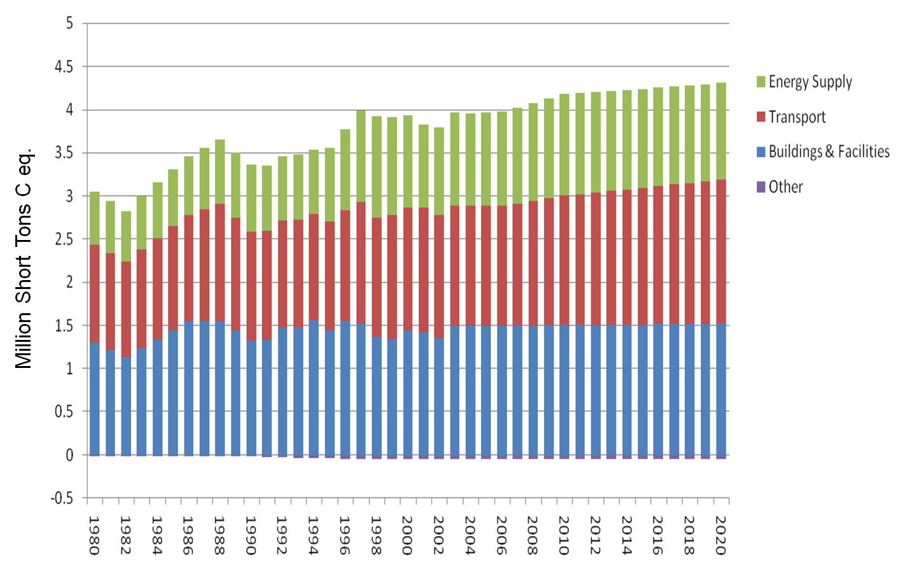

Figure 2: Four Scenarios Compared to Target
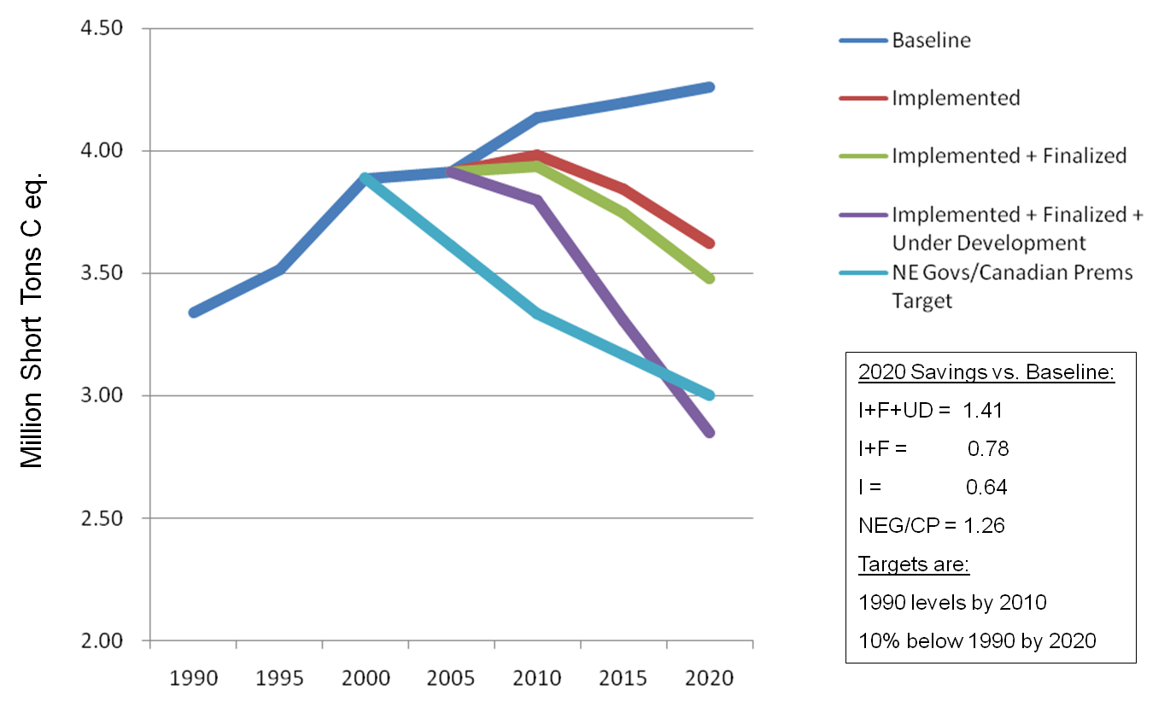

Figure 3: RI GHG Savings By Option in 2020
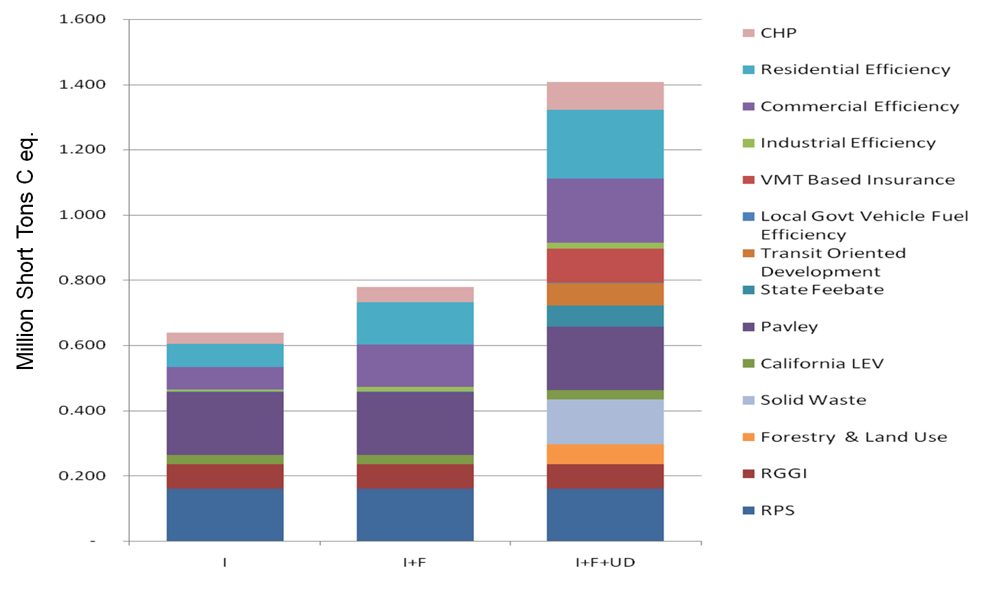

Figure 4: Buildings & Facilities GHG Savings in 2020 vs. Baseline
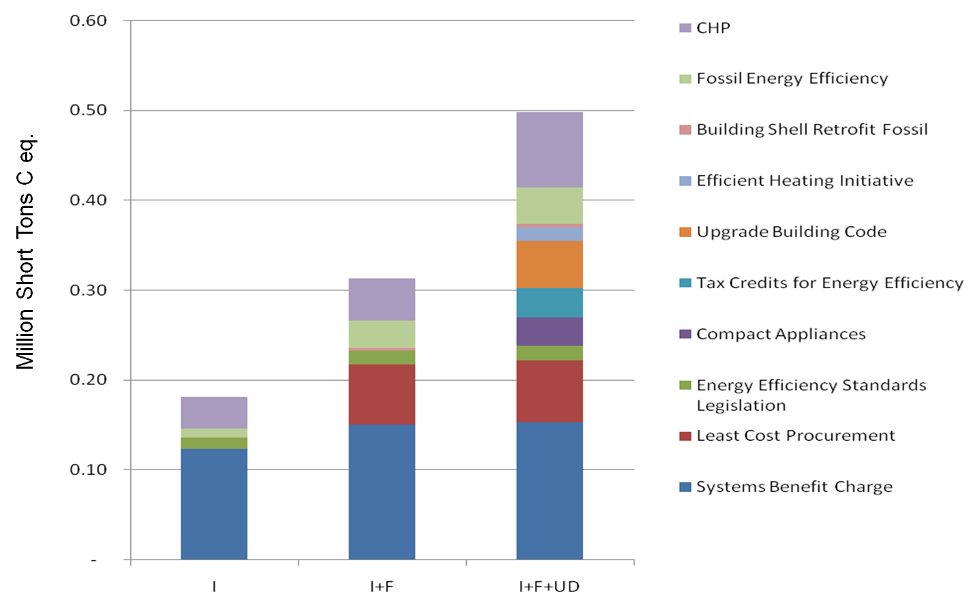

Figure 5: Transport GHG Savings in 2020 vs. Baseline
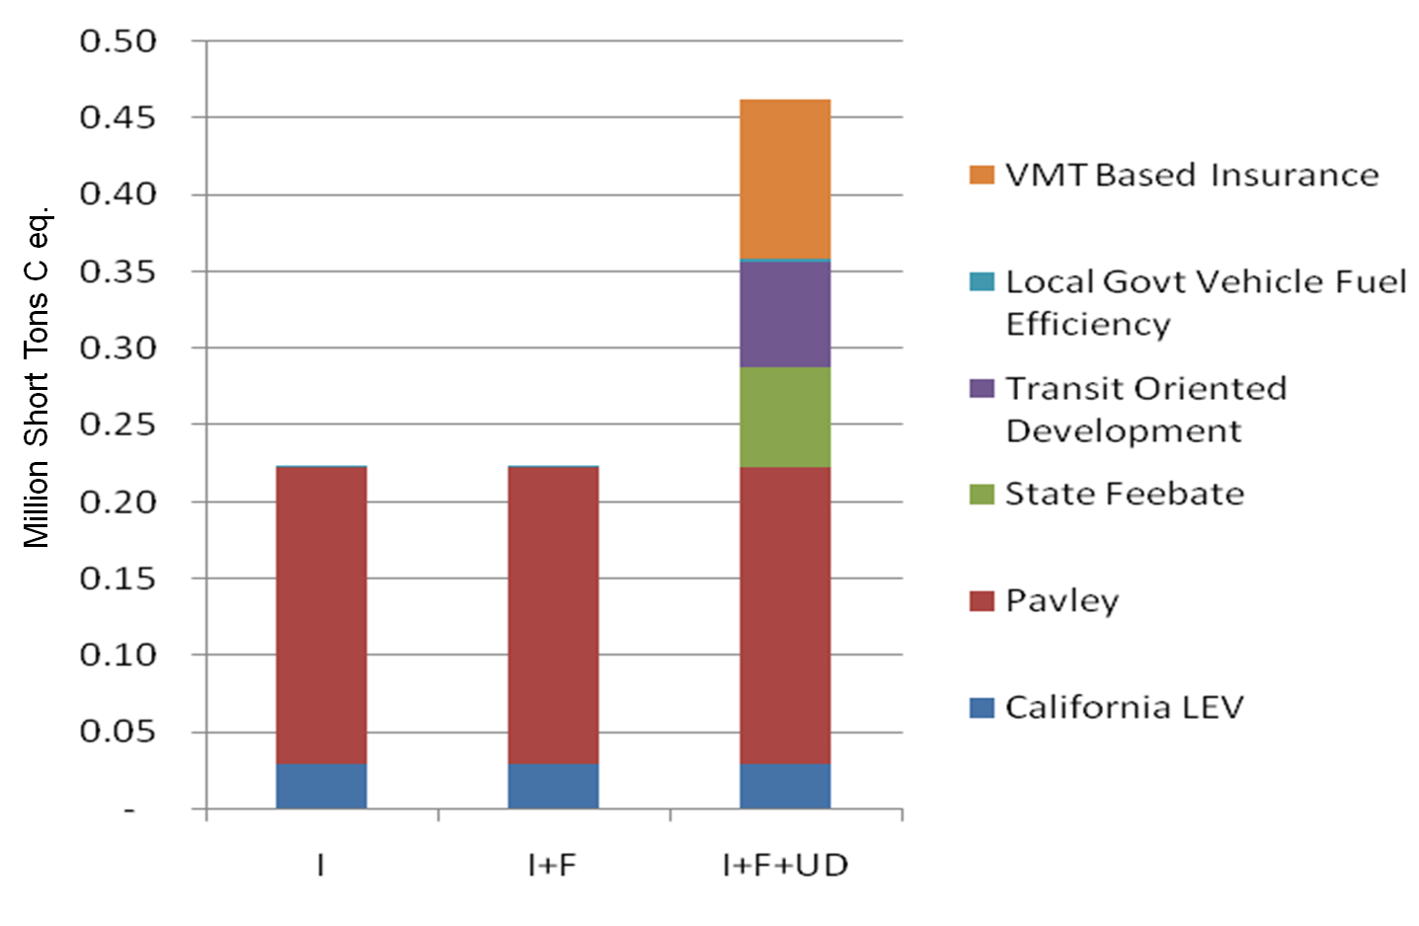

Figure 6: Energy Supply GHG Savings in 2020 vs. Baseline
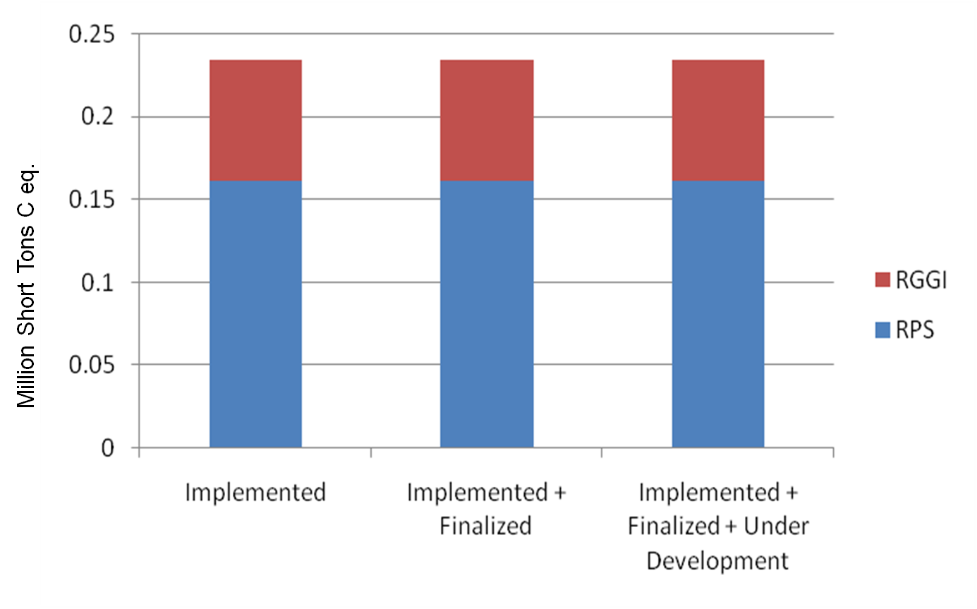

Figure 7: Other Non-Energy GHG Savings in 2020 vs. Baseline
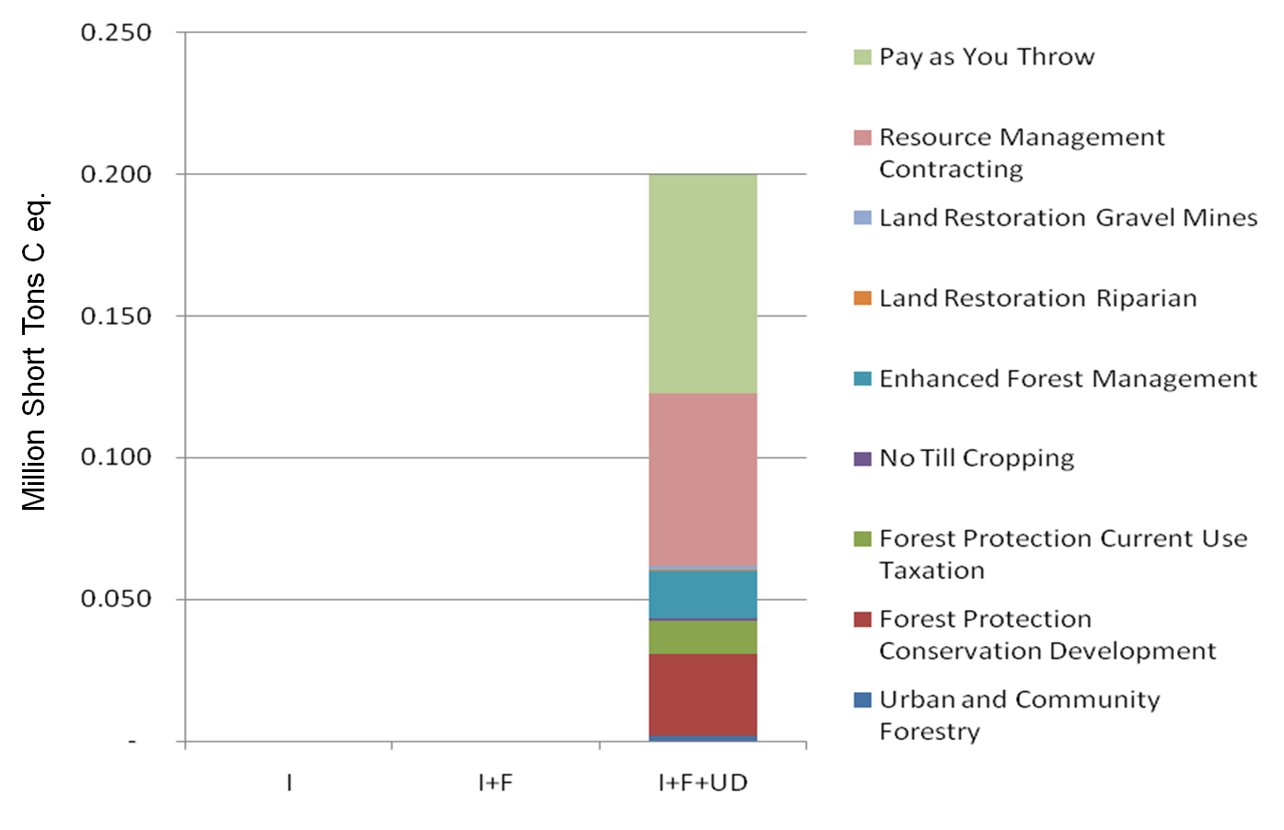

Figure 8: RI Cumulative Net Savings of Three Scenarios
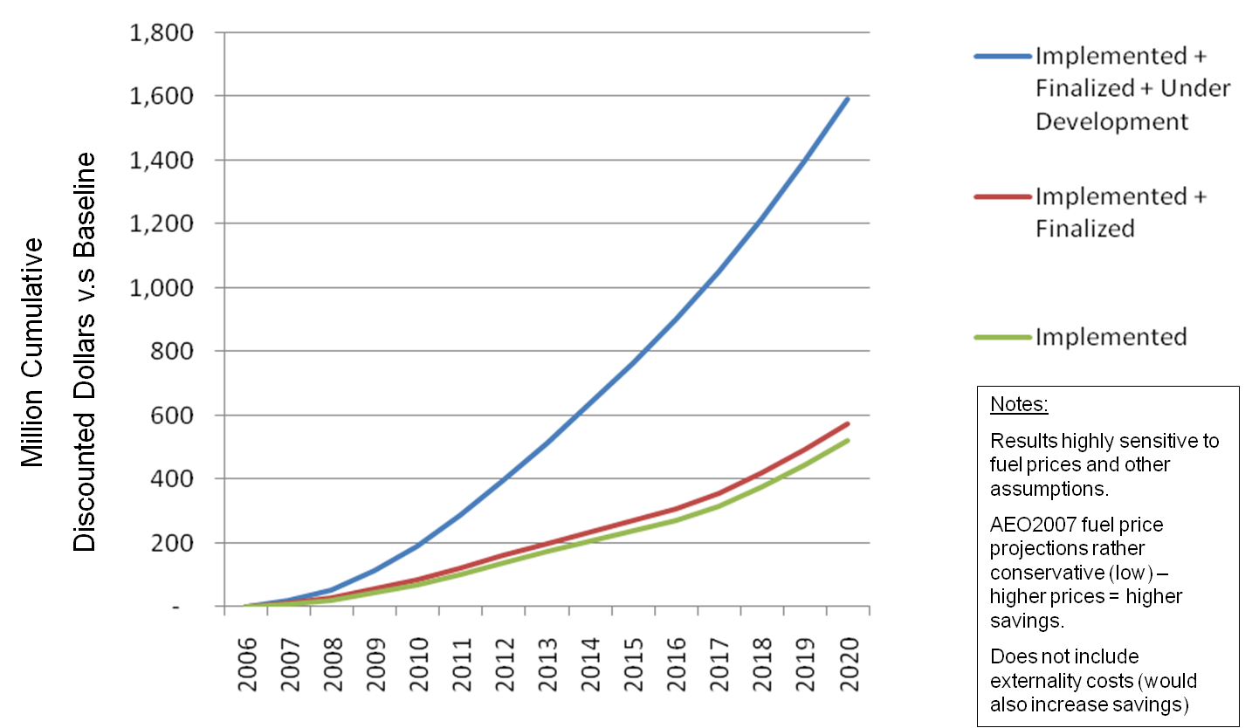

Figure 8: RI Cumulative Costs & Savings by Sector in 2020
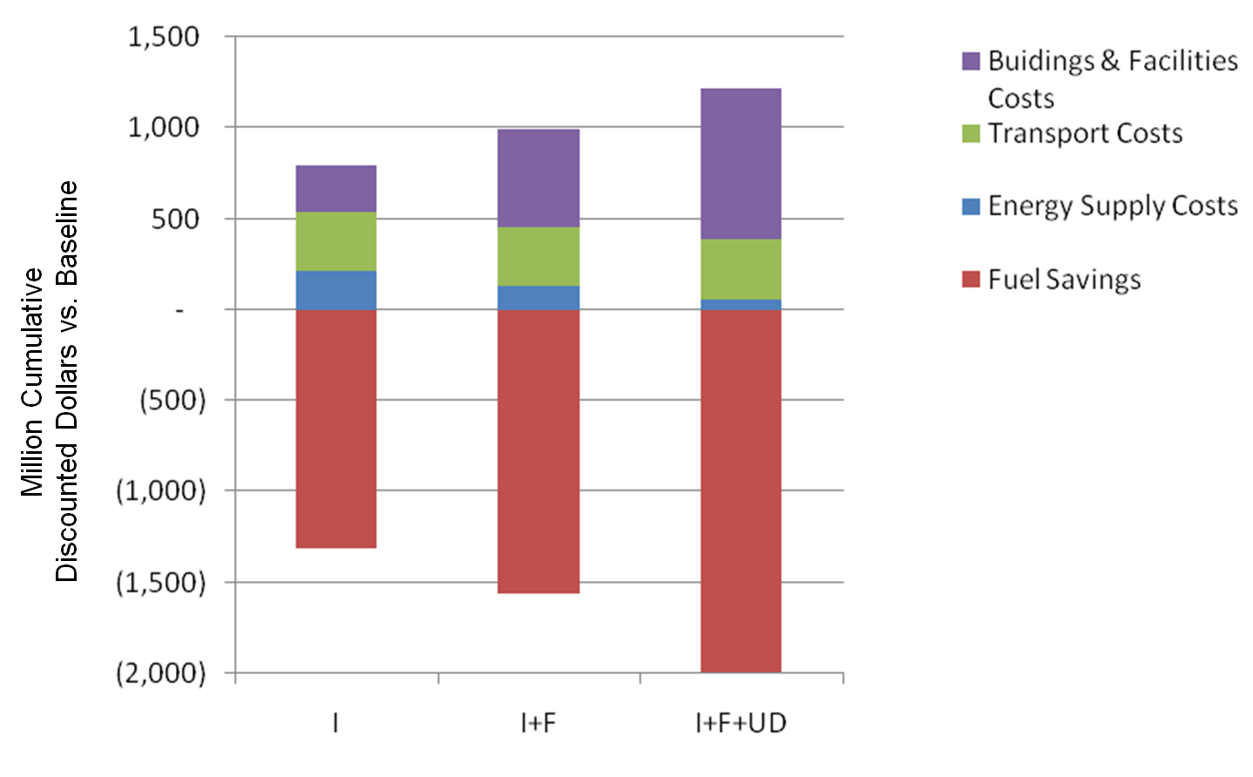

Figure 9: RI Cost Curve : 2020 Cumulative GHG Savings Ordered by Cumulative Cost.
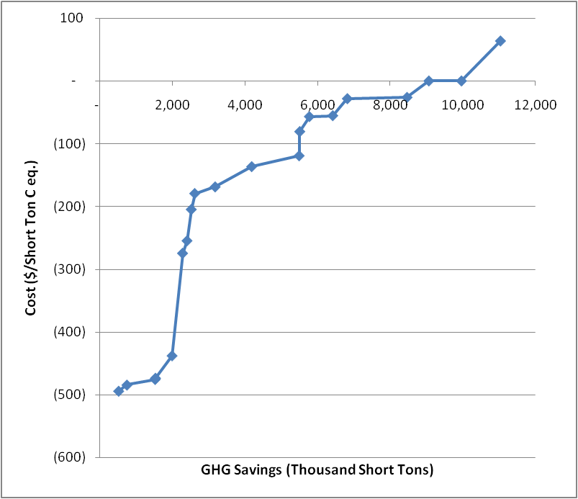

Figure 9: RI Carbon Monoxide Emissions by Scenario
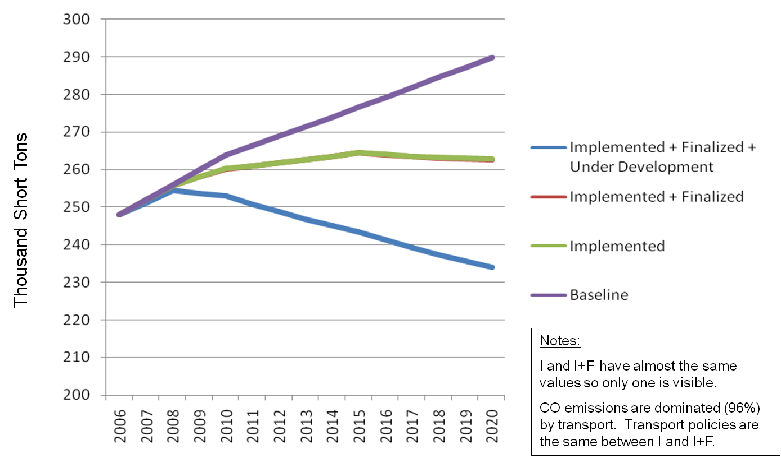
Note: CO and other local air pollutant trends in these charts are based on static emission factors. Emissions reductions are thus only due to the energy savings of the various GHG mitigation measures. The scenario trends do not fully capture any new emission regulations (e.g. for vehicles) that may occur over the scenario timeline and which would likely yield additional emissions reductions.

Figure 10: RI PM10 Emissions by Scenario
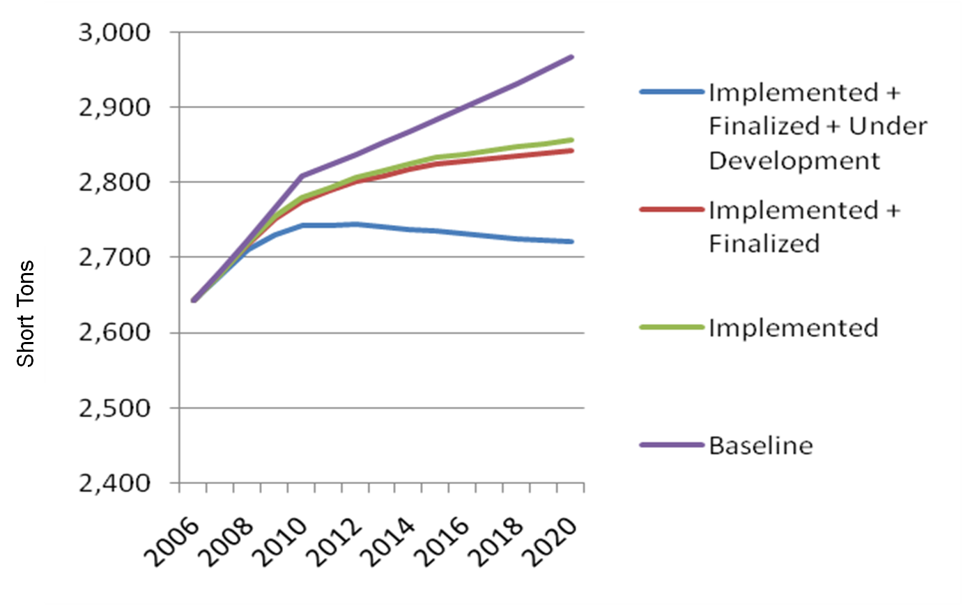

Figure 11: RI VOC Emissions by Scenario
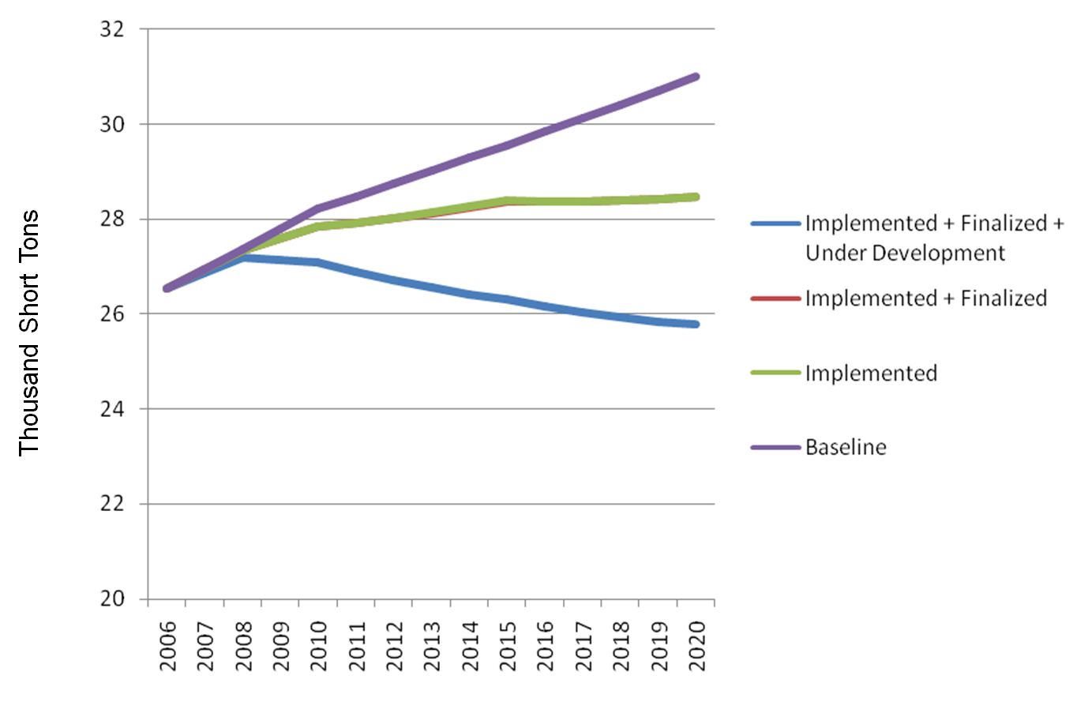

Figure 12: RI SO2 Emissions by Scenario
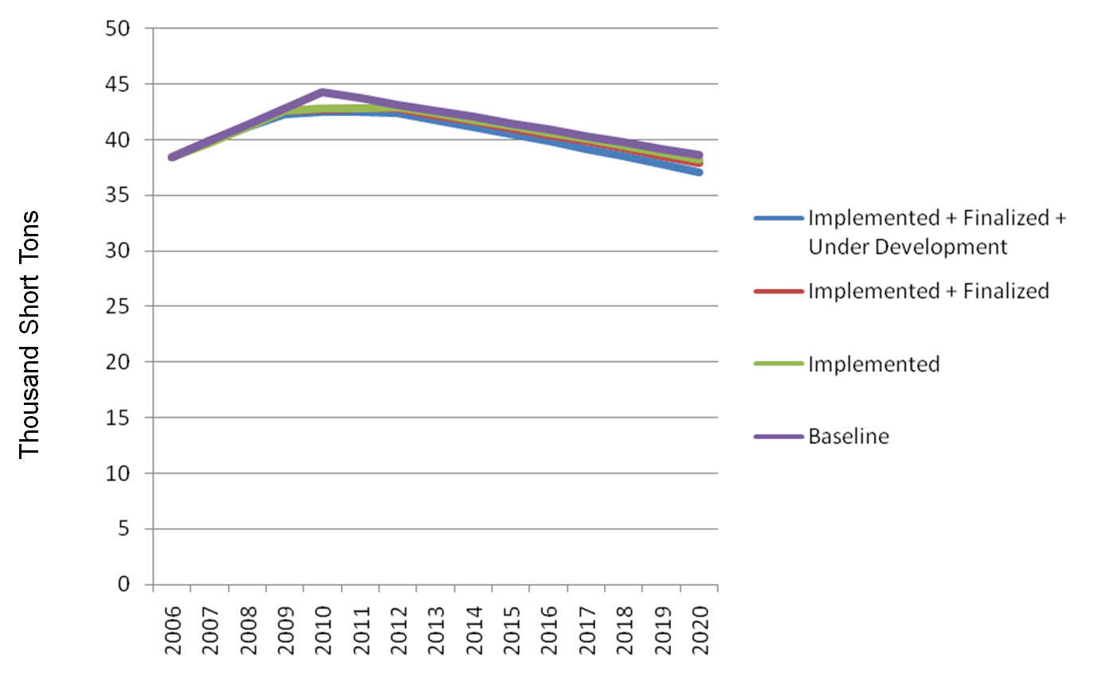

Figure 13: RI NOx Emissions by Scenario
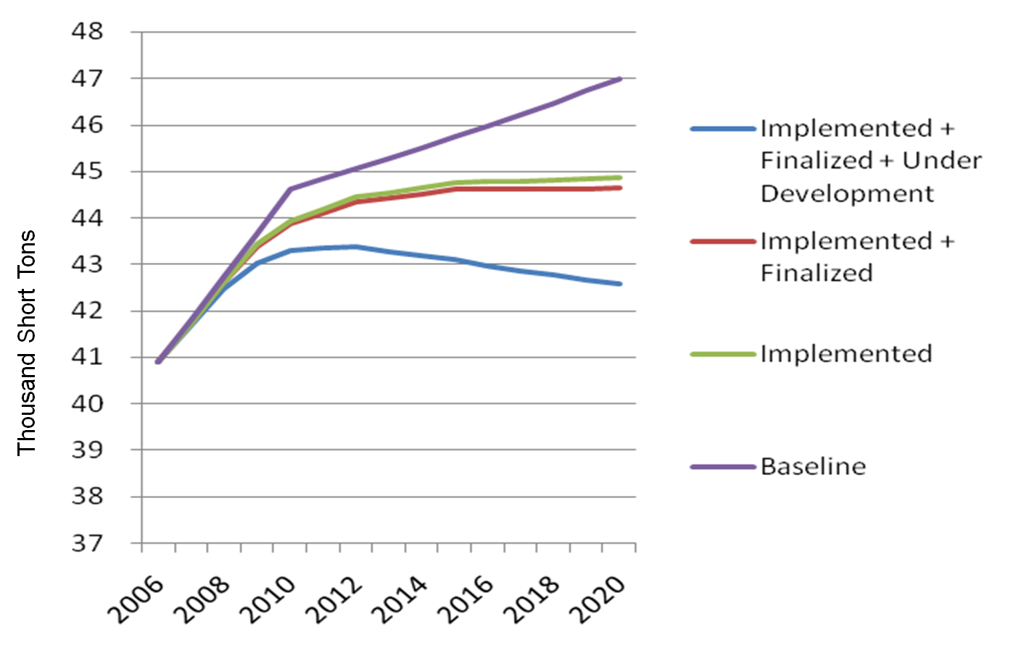

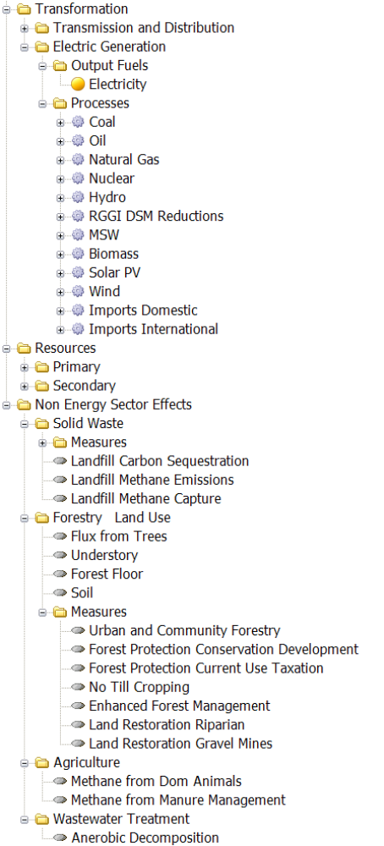
Appendix 1: LEAP RI Data Structure
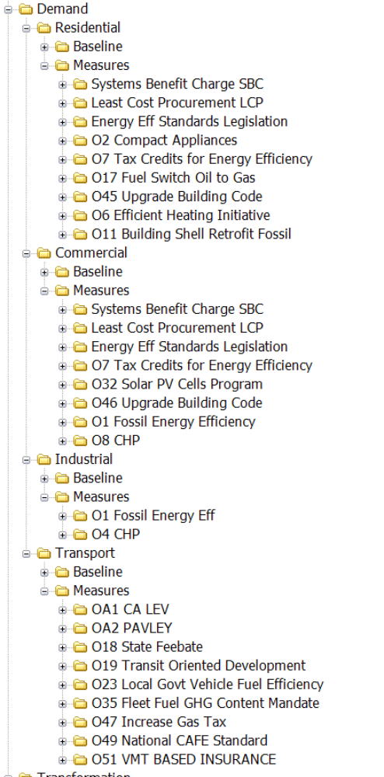

saaa

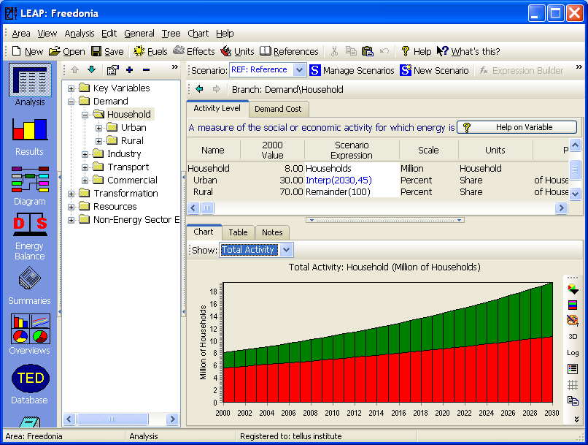
Appendix 2: LEAP
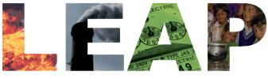
LEAP, the Long range Energy Alternatives Planning system, is an integrated energy-environment modeling tool designed and disseminated by the Stockholm Environment Institute. Its methodology is based on a comprehensive accounting of how energy is consumed, converted and produced in a given region or economy.
At the heart of LEAP is the process of scenario analysis. Scenarios can be built that capture the complexity of human society and a diversity of visions of the future. Unlike econometric or optimization-based models, LEAP’s accounting approach assumes no particular world view and imposes no particular limits on the scenario narrative other than those that are a natural result of the real physical, technical, and scientific constraints on the system being investigated. Using LEAP, scenarios can be built and then compared to assess their energy requirements, social costs and benefits and environmental impacts.
LEAP provides significant advances over earlier generations of modeling tools, by providing intuitive and familiar ways to edit data and review results. LEAP is structured as a series of views of an energy system. In the Analysis View shown above, a tree diagram is used to create data structures for demand, supply and resource analyses. These structures can be edited to reflect the level of disaggregation that is appropriate for the particular application. The tree uses standard operations (copying, pasting, dragging and dropping, etc.) that simplify the construction and maintenance of your data. Intuitive and easy-to-use reporting is another key ingredient of LEAP, helping users to interpret results and catch errors.
LEAP’s transparent methods and easy-to-use design make key energy policy questions easier to grasp. LEAP has thus become an important tool in the training programmes of national and regional energy institutions in all major regions of the world. A range of new training materials have been developed to accompany LEAP, including exercises designed specifically for regional applications (available in local languages). These materials are designed to draw out typical energy-environment policy dilemmas, and to encourage trainees to think about the tradeoffs inherent in different policy options.
Hundreds of government agencies, NGOs and academic organizations worldwide use LEAP for a variety of tasks including, energy forecasting, greenhouse mitigation analysis, integrated resource planning, production of energy master plans, and energy scenario studies. LEAP has been applied at many spatial levels including local rural areas, large metropolitan cities, U.S. States and at the national, regional and global level. Most recently, 85 countries have chosen to use LEAP to assist in their Greenhouse Gas Mitigation Assessments as part of their national communications to the UNFCCC.

Bob Grace, Sustainable Energy Advantage (Renewables); Dan Meszler, Meszler Engineering (Transportation); and David Nichols (Buildings and Facilities). Jonathan Raab, Raab Associates. Ltd. is the mediator for the RI GHG Stakeholder process and overall project manager.
This is a conservatism with respect to estimating GHG savings. To the extent that more carbon intensive power plants may be on the margin, GHG savings would be greater.

